# Probability & Statistics Overview

1. You have a fair 3-sided die with 3 possible outcomes {1},{2} and {3}.
   1. If you roll the die once, what is the probability of obtaining a 3?
   2. If you roll the die once, what is the probability of obtaining an odd number?
   3. If you roll the die twice, what is the probability of obtaining [1,1]?
   4. If you roll the die twice, what is the probability of obtaining [1,3]?
2. Given the following table of blood groups and gender

|  |  |  |  |
| --- | --- | --- | --- |
| **Blood Group** | **Males** | **Females** | **Total** |
| **O**  **A**  **B**  **AB** | **22**  **10**  **10**  **8** | **18**  **25**  **3**  **4** | **40**  **35**  **13**  **12** |
| **Total** | **50** | **50** | **100** |

* 1. What is P(B $∩$ Male)?
  2. P(Male)
  3. P(Female|A)

1. The outcome of an American Roulette in the casino is the following:

**1,2,17,27,35,12, 30,11,3,18,0,5,36,14,17,12,21,25,7,13,5,3,15,3**



Assuming that you know for sure that the roulette is fair, is it a good idea to bet for a black number in the next iteration?

1. You toss a normal 6-sided die twice, what is the probability of obtaining the sequence [1,3]?
2. Let say you have a population of people: [Mary, Daniel, Josh, Susan, Michael, Peter, Andreas, Martin, Craig]. Draw a random sample of size 3 out of this population.
3. Classify the following variables describing a human as quantitative or categorical:
   1. ethnicity
   2. height
   3. IQ
   4. gender
4. In the following relationship between variables Temperature and Heart Rate, which one is the independent variable and which one is the dependent variable?

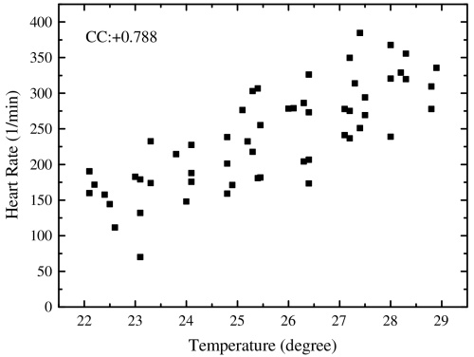

1. For a random variable X we draw a sample S such that S= [5, 6, 1, 3, 8, 9, 2, 3, 3, 4, 9]
   1. Find the mean of S
   2. What is the median of S?
   3. What is the mode of S?
   4. Manually sketch a histogram of the data using bins: [1 to 3], (3 to 6],(6 to 9]
   5. What is the range of the data?
   6. What is the variance of S?
   7. What is the standard deviation of S?
2. In the following distribution of household income, which is higher the median or the mean?

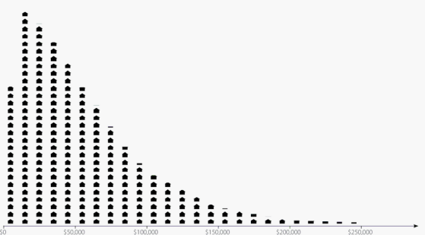

1. In your own words, explain what does grip strength suggests about arm strength according to the following scatter plot? Bonus question: can you infer from this graph that grip strength ***causes*** someone to have a lot of arm strength?

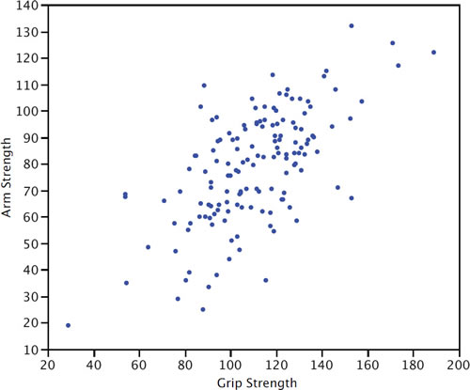

1. Identify which of the following distributions is: uniform, bimodal, positively skew, normal (Gaussian) and negatively skew

